BA BED 4 SEM
EDUCATION
UNIT 4

ALKA ASATI

Intelligence
Intelligence is the ability to think, to learn from experience, to solve problems, and to adapt to new situations.
Intelligence involves some different mental abilities including logic, reasoning, problem-solving, and planning.
The term "intelligence quotient," or IQ, was first coined in the early 20th century by a German psychologist named William Stern. Psychologist Alfred Binet developed the very first intelligence tests to help the French government identify schoolchildren who needed extra academic assistance. Binet was the first to introduce the concept of mental age or a set of abilities that children of a certain age possess.
the intelligence involves the level of ability to do the following:
Learn: The acquisition, retention, and use of knowledge is an important component of intelligence.
Recognize problems: To put knowledge to use, people must be able to identify possible problems in the environment that need to be addressed.
Solve problems: People must then be able to take what they have learned to come up with a useful solution to a problem they have noticed in the world around them.

Nature of Intelligence.
Intelligence is not memory.
An intelligent person may have poor memory.
Intelligence is not a skill which a worker acquires after planned practice. Intelligence is not a guarantee of a good behaviour of the individual.

Edward Thorndike, an American psychologist & his student used objective measurements of intelligence on human subjects.
1920’s he developed a multifactored test of intelligence that consisted of completion, arithmetic, vocabulary, and direction tests (CAVD). It became the foundation of modern intelligence test.
Thorndike drew an important distinction among 3 broad classes of intellectual functioning:

1. Abstract intelligence -Standard Intelligence Tests

2. Mechanical Intelligence- ability to visualize relationship among objects & physical world works.

3. Social Intelligence - ability to function successfully interpersonal situations.

THEORIES OF INTELLIGENCE

UNI FACTOR THEORY OF INTELLIGENCE

THE BINET-SIMONE SCALE Alfred Binet, French Psychologist (1857-1911) - Modern approach to understand the concept of intelligence began with his work together with his colleague.

SPEARMAN’S TWO FACTOR THEORY OF INTELLIGENCE (1904) Charles Spearman, a British psychologist (1863-1945), advanced the two-factor theory of intelligence “g” and “s”. performance of any intellectual act requires some combination of “g” general factor which is available to the same individual degree for all intellectual acts and “s” or specific factors which are specific to that act & which varies in strength from one act to another.
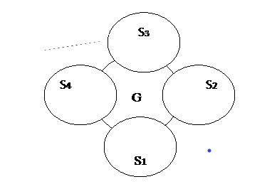
intelligence comprises both a single, pervasive reasoning ability, a general factor, that is used on a wide variety of tasks and a number of narrow abilities, specific factors, involved in executing particular tasks.
• The theory explains that if one knows how a person performs on one task that is highly saturated with “g”, one can safely predict a similar level of performance for another highly “g” saturated task.Prediction of performance on task with high “s” factors is less accurate.The most important information to have about a person’s intellectual ability is an estimate of his “g”

