BABED 2 SEM
ENVIRONMENT
UNIT – 4
ALKA ASATI
Global warming

Global warming refers to the recent and ongoing rise in global average temperature near Earth's surface. It is caused mostly by increasing concentrations of greenhouse gases in the atmosphere. Global warming is causing climate patterns to change. However, global warming itself represents only one aspect of climate change.

Global warming
In the early 1960s scientists recognized that carbon dioxide in the atmosphere was increasing. Later they discovered that methane, nitrous oxide and other gases were rising. Because these gases trap heat and warm the Earth, as a greenhouse traps heat from the sun, scientists concluded that increasing levels of “greenhouse gases” would increase global warming.
greenhouse gases such as:
carbon dioxide, methane, and nitrous oxide. Fossil fuel etc

Over the last 50 years, the global climate is changing as the Earth becomes warmer. Atmospheric concentrations of both the natural and man-made gases have been rising over the last few centuries due to the industrial revolution. Human activities have released sufficient quantities of carbon dioxide and greenhouse gases to affect global climate.

increased temperature trends described by global warming, but also encompass changes such as sea-level rise; ice mass loss in Greenland, Antarctica, the Arctic and mountain glaciers worldwide; shifts in flower/plant blooming; and extreme weather events.

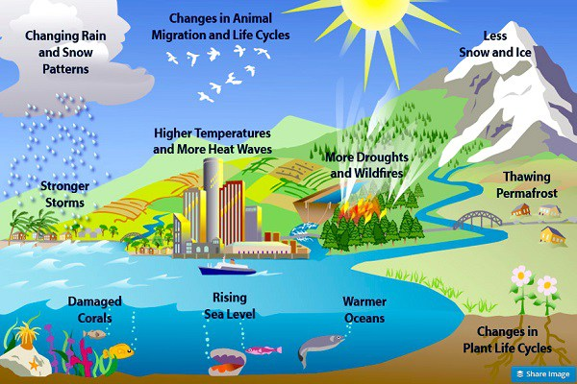

The effects of global warming include rising sea levels, regional changes in precipitation, more frequent extreme weather events such as heat waves, and expansion of deserts.
Surface temperature increases are greatest in the Arctic, which have contributed to the retreat of glaciers, permafrost, and sea ice.
Overall, higher temperatures bring more rain and snowfall, but for some regions droughts and wildfires increase instead.
Climate change threatens to diminish crop yields, harming food security,

